IT 697 SQL Module Three Reflection Journal

Michael Surdek

Southern New Hampshire University

The third week of this experiential learning course was a challenge for me, mostly due to the fact that I am vacationing with my family in Mexico for one week through next Saturday. I am taking the time off from my full-time job, which meant I was extremely busy this week essentially trying to complete two weeks of my workload in one. I have been able to complete the discussion and assignments for my other graduate course and I have been able to dedicate at least 6 hours to my SQL learning experience. Although this will likely be fewer hours than I need to aim for on an average weekly basis, I feel like I made the most of my opportunity this week and I am keeping myself on a good track to accomplish what I need to in this experience.

I began the week exploring the resources posted in Module Three, which included many useful videos and tutorials about the WHERE clause. I am familiar with the purpose of the WHERE clause, which is to filter for rows that meet certain criteria, from my experience working with data in R. The filter() function in R is very similar to the WHERE clause in SQL. Something that was newer to me this week was seeing the WHERE clause used with things other than the standard logical operators. Examples of this included, IN, BETWEEN and LIKE.

As I was travelling on Saturday, I knew that I still had to put many more hours into this week’s learning experience, so I decided to check out if there were any podcasts that taught or discussed SQL in some way. I thought this would be a good way to spend my time on the planes because I could download the podcast to my phone. I also believe podcasts are a great way to learn something new because you are hearing comprehensively and directly from someone with relevant experience. I found three podcasts that were either based entirely around SQL or contained episodes about SQL: Learn to Code in One Month, SQL Server Radio, and SQL Data Partner Podcast. I spent just a little over an hour listening to two episodes of Learn to Code in One Month and one episode of SQL Server Radio. In that short amount of time, I learned about the top reasons to learn SQL and some recommendations on the best ways to learn SQL, and I listened to a data scientist who talked about the importance of integrating tools such as SQL and R and discussed other best practices when it comes to deriving insights from data. These podcasts were a great way to spend time on this learning experience where I otherwise would have not been able to do so on the airplane, and I have already identified more podcast episodes that I might be able to incorporate in future weeks of this course.

Since I considered my venture into SQL podcasts a success in terms of this course’s objectives, I decided to consider other potentially unorthodox learning methods, outside of textbooks and online tutorials. The first is the subreddit r/SQL. Subreddits are communities of shared interests where people of all backgrounds and experience levels can participate in discussion boards and interactive threads. I have browsed r/SQL in the past, but had not considered incorporating it into this learning experience. Starting in week 4, I am planning to read through the posts and comments in r/SQL so that I can become acquainted to common or even unusual discussion points regarding SQL. If I come across something appropriate in a certain week, I would definitely create my own thread in an attempt to gather feedback and comments from experienced SQL users from all over the world.

The second unorthodox method I considered for learning SQL is live streams on Twitch or Youtube. These are not polished tutorial videos, but rather someone live coding and interacting with a real database for a legitimate purpose. I have watched coding streams on Twitch and Youtube from programmers using both R and Python, so I decided to find out if anyone was doing a similar thing with SQL. I came across a Youtube stream from Amazon Web Services called “Live Coding with AWS | SQL vs. NoSQL”. In the stream I watched a man write queries to create a schema and tables for a database that contained over 400 Million data points regarding political/wolrdwide events such as Presidential speeches or military invasions. The man then wrote queries to interact with the database to retrieve information such as the count of events per year between Barack Obama and Vladimir Putin. I was surprised to see how although the queries might look complex because of the table/variable names and numerous lines of code, they were actually quite simple and I was mostly able to understand how they functioned just from learning the clauses that we have covered in this course. One of my favorite things about this particular learning method is that you get the full experience watching someone code in real time. It is clear to see that code is often not perfect on the first try, and in these streams you get to witness the debugging process. It is possible to learn a lot from the live debugging process, because it is like you are inside the streamers head for a second. When you are trying to learn from tutorials and textbooks, you don’t usually see what it looks like when things don’t go as expected.

One thing that was included in the podcast of recommendations on the best ways to learn SQL, and as I have mentioned in my previous reflections, is that the best learning method is simply practicing. For this reason, I concluded my weekly learning experience with some brief practice in the APEX Oracle engine in an attempt to execute the WHERE clause. I struggled at first with the WHERE clause as I received the error “ORA-00933: SQL command not properly ended”. I eventually realized I needed to add the WHERE clause after the JOIN clause and I was able to build on my previous query to only select the exams which had an exam time that was less than 11. Here is my query and its result:

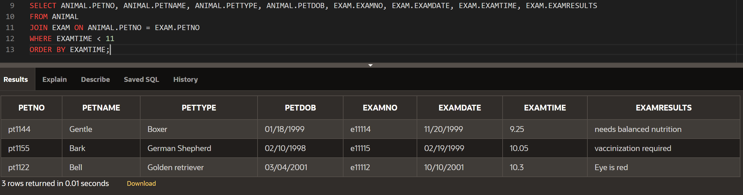

The final thing that I wanted to reflect on is the feedback I received from last week’s reflection which advised that I add references in my reflection. I plan to incorporate quotations and citations into my reflection going forward with the hopes of communicating my efforts and experiences more strongly. To do this, I plan to add materials such as articles and academic papers that might be relevant to this learning experience, on top of the current types of materials I have been using. For example, I found an article called “The New Languages of Business: Python, SQL, R” from the Colombia Business School at colombia.edu. Articles and papers like this will add to my learning experience and help me create a stronger and more robust weekly reflection.

Project/Coursework Tracker

* Company requirements -> database schema
  + Planning to start in week 4
* Live scoreboard/rankings of some kind
  + Not started